UNDERGRADUATE FINAL YEAR PROJECT REPORT
Department of Computer Science and Information Technology NED University of Engineering and Technology



Threat Intelligence Automation from Dark Web Sources

Group Number: CS-22052 Batch: 2022-2026

Group Member Names:

Hafsa Ali CR-22006
Dania Fazal CR-22007
Sarah Zafar CR-22025
Hashem Raed Mohammed Alawi Al-Sakkaf CR-22050

Approved by
. . . . . . . . . . . . . . . . . . . . . . . . . . . . . . . . . . . . . . . . . . . . . . . . . . . . . . . . . . . . . . . . . . . . . . . . . . . . . . . . . . . . . . . . . . .
Dr Muhammad Mubashir Khan Chairman CSIT Department
Project Advisor

© NED University of Engineering & Technology. All Rights Reserved – [November 2025]

Author’s Declaration

We declare that we are the sole authors of this project. It is the actual copy of the project that was accepted by our advisor(s) including any necessary revisions. We also grant NED University of Engineering and Technology permission to reproduce and distribute electronic or paper copies of this project.

Hafsa Ali

CR-22006

hafsa.a.mehboob@gmail.com
Dania Fazal

CR-22007

daniafazal39@gmail.com

Sarah Zafar

CR-22025

sarahzafar101@gmail.com
Hashem Raed Mohammed Alawi Al-Sakkaf

CR-22050

hashem.alsakkaf2004@gmail.com

Statement of Contributions

Hafsa Ali

Hafsa helped in testing and validating the crawler during the initial development phase and doc- umented the crawling results thoroughly. She also contributed to the background study, problem identification, and helped compile the comparative review of existing dark-web crawlers.

Dania Fazal

Dania initiated and developed the core crawler logic, coding the link extraction module and imple- menting the crawling pipeline that navigates onion sites and retrieves HTML content. She also visited dark-web websites to prepare and design the seed-file mechanism used to guide the crawler’s initial entry points.

Sarah Zafar

Sarah provided support during the initial stages of the project by helping with basic research and planning, contributing inputs to the documentation, and helped in designing the workflow diagrams. She helped structure the written components of the project and maintained their flow.

Hashem Raed Mohammed Alawi Al-Sakkaf

Hashem enhanced the crawler by adding a content-capture folder mechanism and improving data- management workflows, ensuring smooth handling of multiple onion sites during crawling. He re- fined how extracted content, URLs, hashes, and captured pages were organized, stored, and tracked, ensuring better traceability and consistency.

Executive Summary

Detecting cyberthreats on the dark web is the focus of this project. Hackers often share hacking tools, malware, and stolen data on the dark web. The problem is that legitimate organizations often do not have sufficient tools to detect threats before they become an issue, because the sophistication and speed of cybercrime are developing faster than traditional monitoring will allow. This project presents an active solution for monitoring the dark web because the system is capable of monitoring, identifying, gathering, and analyzing dark web activity. The system has been built to act indepen- dently by collecting and processing the dark web, presented as a solution for the problem. With the

threat of security-related transgressions continuing to grow and human monitoring becoming slow, cumbersome, and untenable, there is a definite need for automated methods to objectively and con- sistently identify emergent threats, and to be able to make sense of underground forums. The system also requires determining, as a first step, which dark web sites to monitor. It is programmed to use the Tor network to crawl any site selected to harvest text-based data. Natural Language Processing (NLP) cleans the text data collected, identifies critical attributes, and extracts information such as stolen cre- dentials, indicators for malware, and other potential signs of warnings. The data is collected and stored in a database with a structure that allows for analysis and anomaly/pattern identification. The

system demonstrates that automated monitoring can be effective, while it is impossible for a human, committee, or organization to recognize the indicators for immediate threats identified, classify the references to threats, and predict the potential harm through mining for patterns that would not be possible without automation.

Acknowledgments

We would like to thank Sir Dr. Muhammad Mubashir Khan and Miss Saadia Arshad for their continuous guidance and support throughout this project. Their helpful advice made it easier for us to understand the work and stay on the right track. We are also grateful to them for providing the data

and supporting material that we needed. Their cooperation and encouragement played an important role in helping us with this project successfully.

Contents

Author’s Declaration i

Statement of Contributions ii
Executive Summary iii
Acknowledgments iv
List of Figures vii
List of Tables viii
List of Abbreviations ix
United Nations Sustainable Development Goals x
Similarity Index Report xi
- Introduction 1
  - Background Information 1
  - Significance and Motivation 1
    - Supporting Evidence & Market Context 1
    - Why Obscura Matters - High-Level Impact 2
  - Aims and Objectives 3
  - Methodology 3
    - Phase 1: Requirements and Planning 3
    - Phase 2: Data Collection 4
    - Phase 3: Data Preprocessing and Threat Detection 4
    - Phase 4: Data Storage 4
    - Phase 5: Visualization 5
    - Phase 6: Testing and Evaluation 5
    - Gantt Chart 6
  - Report Outline 7
    - Scope of the Project 7
- Literature Review 8
  - Introduction 8
  - Dark-Web Threat Intelligence Landscape 8
  - Additional Crawlers and CTI Systems 8
    - Dizzy: Large-Scale Onion Service Crawler 8
    - Snowball-Miner: Deep Learning for Dark-Web CTI 9
    - CRATOR: Dark-Web Intelligence and Crawler System 9
    - Ahmia: Onion Search Engine for Tor Services 10
    - ACHE Crawler for Tor 10
  - Gaps and Research Opportunities 11
  - Positioning Obscura 11
  - Comparison Criteria 12
  - Comparative Analysis of Existing Tools 13
- System Architecture & Design 14
  - Introduction 14
  - Functional Requirements 15
  - Non-Functional Requirements 16
  - Current State of Obscura 17
  - UML Diagrams 18
    - Use Case Diagram 18
      - Notation and Element Details 19
    - Sequence Diagram 19
    - Activity Diagram 22
    - Entity-Relationship Diagram 24
      - Users 24
      - Seeds 25
      - Results 25
      - Loaded Pages 26
      - Archive 26

List of Figures

- Expected Gantt Chart 6
- Actual Gantt Chart 6
- Usecase Diagram 18
- Sequence Diagram 20
- Activity Diagram 22
- Entity-Relationship Diagram 24

List of Tables
- Comparison of Dark Web Crawling Tools Against Key Criteria 13
- Functional Requirements of Obscura 15
- Non-Functional Requirements of Obscura 16

List of Abbreviations

AI | Artificial Intelligence
SDG | Sustainable Development Goals
FYDP | Final Year Design Project
NLP | Natural Language Processing
IOC | Indicators of Compromise
CTI | Cyber Threat Intelligence
ML | Machine Learning

United Nations Sustainable Development Goals

United Nations Sustainable Development Goals
The Sustainable Development Goals (SDGs) are the blueprint to achieve a better and more sustainable future for all. They address the global challenges we face, including poverty, inequality, climate change, environmental degradation, peace, and justice. There are a total of 17 SDGs as mentioned below.
Check the appropriate SDGs related to the project.

- No Poverty
- Zero Hunger
- Good Health and Well-being
- Quality Education
- Gender Equality
- Clean Water and Sanitation
- Affordable and Clean Energy
- Decent Work and Economic Growth
- Industry, Innovation, and Infrastructure
- Reduced Inequalities
- Sustainable Cities and Communities
- Responsible Consumption and Production
- Climate Action
- Life Below Water
- Life on Land
- Peace and Justice and Strong Institutions
- Partnerships to Achieve the Goals

Similarity Index Report

Following students have compiled the final year report on the topic given below for partial fulfillment of the requirement for Bachelor’s degree in Computer Science & Information Technology.

Project Title: Threat Intelligence Automation from Dark Web Sources

S. No. Student Name Seat Number

- Hafsa Ali CR-22006

- Dania Fazal CR-22007

- Sarah Zafar CR-22025

- Hashem Raed Mohammed Alawi Al-Sakkaf CR-22050

This is to certify that Plagiarism test was conducted on the complete report, and overall similarity index was found to be less than 20%, with a maximum 5% from a single source, as required.

Signature and Date

Dr Muhammad Mubashir Khan

Chapter 1 Introduction

Background Information
In recent years, cybercrime activities have increasingly shifted to underground marketplaces and fo- rums hosted on the dark web Fuentes, 2025. These hidden platforms are trading places for stolen data, malware, zero-day vulnerabilities, and illegal hacking tools. Organizations have limited visibility into emerging threats due to the anonymity of Tor network and other dark web infrastructure, often finding breaches or exploits only after significant damage has been done. Conventional threat intelligence systems primarily focus on surface and deep web sources,which results in a significant intelligence gap regarding underground criminal discussions. To address this gap, this project (Obscura) proposes

to develop an automated threat intelligence system that collects, analyzes, and visualizes cyber threat data from deep web content in the form of browsing websites using web scraping, Natural Language Processing (NLP), and data visualization. The aim of this system is to improve the identification of cyber threats for earlier detection, and improve situational awareness for cybersecurity professionals, all by converting dark web content into structured information for actionable insights.

Significance and Motivation
Dark web intelligence has become an indispensable part of modern cybersecurity operations. The dark web—particularly Tor-based onion sites, underground forums, and illicit marketplaces—serves as a fertile ground for cybercriminals to trade stolen credentials, malware, exploits, and even coor- dinate future attacks. This unregulated, anonymous space poses a major visibility gap for security teams and organizations. Manual monitoring of these sources is untenable: there is simply too much volume, too much churn, and too much risk, making automated intelligence collection not just bene- ficial but critical.
Obscura is motivated by this pressing need: to automate dark web threat intelligence gathering, sig- nificantly reduce human burden, speed up detection, and improve the quality and context of cyber- security insights. By combining crawler technology, artificial intelligence (particularly NLP), and threat analytics, Obscura allows security teams to shift their focus from reconnaissance to action — from raw data to proactive defense.

Supporting Evidence & Market Context
      - The dark web intelligence market is growing very fast. According to market research, it was worth USD 520 million in 2023, with forecasts estimating it will reach USD 2,921 million by 2032 (CAGR ≈ 21.8%) “Dark Web Intelligence Market News”, 2025.

      - On the dark web, leaked information comprises a large chunk: as per SQ Magazine, 28% of dark web listings are data leaks, while stolen financials account for 12%, and hacked accounts 3% “Dark Web Statistics”, 2025.
      - The scale of data exposure is massive: Collection #1, one of the largest aggregation leaks, held over 773 million unique email addresses and 21 million unique passwords, totaling more than
2.7 billion email/password pairs “Collection No. 1”, 2025.
      - In terms of research methodology, a systematic literature review found that automated crawling is used in about two-thirds of dark web forum studies, and more than 90% of these used Python- based tools, highlighting both the prevalence and scalability of automation Patra, 2025.

Why Obscura Matters - High-Level Impact
      - Reducing Human Burden & Risk
        - Security analysts often lack the bandwidth to manually scan hundreds or thousands of dark web sources. Automated crawling and NLP reduces this manual burden, freeing up human analysts to focus on investigation and mitigation.
        - Automation also mitigates risk: instead of having humans browse dangerous onion sites (which can be risky and legally ambiguous), crawlers can do the heavy lifting in a con- trolled, secure environment.
      - Speed & Timeliness
        - Real-time or near real-time data collection ensures faster detection of emerging threats (zero-day leaks, new malware, newly registered marketplaces).
        - Integration with SIEM/SOC means threat intelligence can be actioned rapidly, enabling proactive defense — blocking or monitoring indicators before they escalate into attacks.
      - Quality & Context
        - Using NLP to filter irrelevant chatter (only 20% is CTI-relevant) ensures that analysts see high signal, not noise Schro¨er et al., 2025.
        - Profiling threat actors over time adds strategic context: which aliases come up repeatedly, what tools they use, which marketplaces they frequent — enabling attribution, prioritiza- tion, and long-term threat modeling.
      - Scalability & Sustainability
        - As the dark web grows (both in volume and volatility), automated architectures (e.g., big data pipelines, deduplication, clustering) make continuous, resilient monitoring feasible.
        - This kind of intelligence system scales better than manual methods and can adapt more flexibly as new forums or marketplaces appear or disappear.
      - Contribution to Broader Cyber Resilience
        - By feeding structured threat intelligence into existing security workflows, Obscura helps organizations move from reactive to proactive security.

        - It aligns well with capacity building and infrastructure goals: as cyber defense becomes more data-driven, organizations can better anticipate and mitigate digital risks — con- tributing to SDG 9 (Industry, Innovation, and Infrastructure) by strengthening digital in- frastructure and innovation in threat prevention.

Aims and Objectives
The project aims to create and deploy a platform for automated cyber threat intelligence that scrapes, processes, and provides cyber threat intelligence from the dark web. The main goals are:
- Automated Dark Web Crawling: To create web crawlers that are safe to ethically scrape pub- licly available onion sites and forums and marketplaces for any information related to threats.
- NLP based Entity Extraction: Using Artificial Intelligence to process the collected data in order to extract and classify its potential entities, such as malware name, exploit, stolen creden- tials, CVE identifiers.
- Threat Classification and Detection: Machine learning is used to sort the text into threat types like malware, phishing, or data breaches and to spot possible indicators of compromise.
- Visualization of Threat Trends: Dashboards built with tools such as Kibana help show the major threats, affected domains, and any new attack patterns.
- Threat Actor Profiling and Reporting: To provide contextual intelligence to cyber analysts and connect alias and marketplace activity / trends.

Methodology
This project (Obscura) will be addressing a six-phase methodology that will systematically help with data collection, analysis, and visualization of data collected from the dark web. Each of these phases has an important role in the scope of converting raw unstructured data to usable cyber threat intelli- gence

Phase 1: Requirements and Planning
This phase includes defining research objectives, system architecture, and operational workflow. Some of the key tasks include the identification of relevant dark web sources (e.g. marketplace, forum, discussion board) where cybercriminal activity is taking place.
This will provide a taxonomy of threat categories that includes malware distribution, data breaches, stolen credentials, phishing campaigns, and exploit trading, among other items, to guide data extrac- tion and classification.
The system design includes modules for data collection, NLP-based analysis, storage, and visualiza- tion.
All legal and ethical guidelines for dark web research are reviewed to ensure compliance with security and academic integrity standards.

Phase 2: Data Collection
In this phase, development of automated crawlers capable of navigating Tor-based onion sites takes place using technologies and python libraries like Tor Browser,Selenium, Beautiful Soup and Sele- nium
By using these tools, crawler scrapes textual data from publicly accessible dark web pages while avoiding restricted or illegal content. The crawler also handles irregular site structures, dynamic content, and intermittent availability.
Collection of data includes forum posts, product listings, user aliases, and transaction details related to cyber threats.
To keep the information useful, the crawler applies an initial layer of filtering. It highlights posts containing terms such as “exploit,” “malware,” “credential dump,” or “data leak,” so irrelevant content is reduced before the data moves into deeper analysis.

Phase 3: Data Preprocessing and Threat Detection
This is the core analytical phase of the project which consists of the following processes:
      - Cleaning and Preprocessing of Data: This step involves the cleaning process, during which the texts will be stripped of extraneous HTML tags, advertising information, duplicates and un- related content. Normalization and the removal of stop-words will be conducted in conjunction with the preprocessing of the data during the Cleansing phase; we will rely on NLP libraries like SpaCy to handle language-specific pre-processing.
      - Extraction of Indicators of Compromise (IOCs):The processes of extracting IOCs involves the identification of potential threat vectors such as IP addresses, domains, CVE identifiers, cryptocurrency wallets, and file hashes, largely using regex and entity recognition.
      - Threat Classification: Based on the posts’ content, indicative keywords are utilized to classify posts either based on keywords or using a ML-based model. The posts will be categorized within the reference type of threats either malware, exploits, data breach or phishing.
      - MITRE ATT&CK Mapping: The process of MITRE ATT&CK mapping involves map- ping the extracted and identified IOCs and behavioral data to MITRE ATT&CK Tactics and Techniques to connect the discussions to attacker behaviors reported in real life.
This pipeline allows for the noisy and unstructured dark web data to be transformed into structured and useful and meaningful intelligence.

Phase 4: Data Storage
The processed data is stored in a centralized Elasticsearch database to allow efficient indexing, search- ing, and querying of intelligence records.
Each entry is tagged with metadata such as source URL, timestamp, detected entity types, and threat categories.This repository functions as a threat intelligence knowledge base, supporting historical trend analysis and identification of recurring threat actors or campaigns.

Phase 5: Visualization
The visualization module transforms the processed data into interactive dashboards displayed in Kibana.
Some of the key data visualizations include:
      - Frequency of the malware families discussed.
      - Most mentioned CVEs and impacted software.
      - Top dark Web marketplaces and forums referenced in cybercrime.
      - Time-based trends of spikes of discussion related to specific tools, attacks.
The visualizations provide analyzable insights so that an analyst can identify new attack trends and use them as intelligence to proactively defend against such threats.

Phase 6: Testing and Evaluation
The last phase refers to the validation of the system and the performance assessment of the system.

The effectiveness of the system in identifying actual threats while minimizing false positives is as- sessed through a variety of metrics including accuracy, precision, recall, and timeliness.

Comparative testing is completed against public threat feeds that are known to confirm reliability and validity.

User feedback from supervisors and peer reviewers informs improvements to crawling performance, accuracy of NLP, and the presentation of the dashboard.

Overall, evaluation of the system identifies that the system satisfies its objectives and plays a mean- ingful role in the automated dark web threat intelligence research.

Gantt Chart
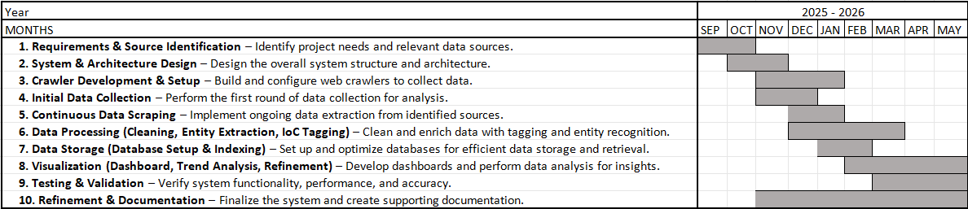
Figure 1: Expected Gantt Chart

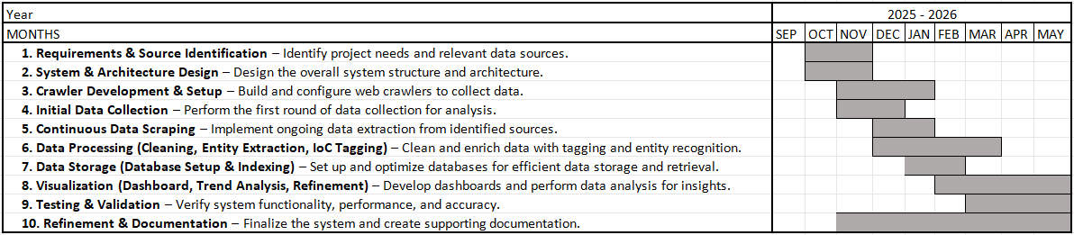
Figure 2: Actual Gantt Chart

Report Outline
This report is organized into several chapters to present a structured overview of the project:
- Chapter 1: Introduction: Provides the background, motivation, problem statement, aims and objectives, methodology overview, and project scope.
- Chapter 2: Literature Review: Reviews existing dark-web crawling systems, CTI extraction techniques, identifies research gaps, and positions the proposed system.
- Chapter 3: System Design and Architecture: Describes the system structure, functional and non-functional requirements, modules, and UML diagrams.

Scope of the Project
The scope of this project is limited to the ethical collection and analysis of publicly accessible dark web data strictly for academic and research purposes. The project will:
      - Focus exclusively on cyber threat intelligence, e.g., leaked credentials, malware advertise- ments, exploits discussions and data breach messages.
      - Crawl and extract data legally and ethically to not engage in illegal activities.
      - Use machine learning and NLP to find indicators of compromise and map those to frameworks like MITRE ATT&CK.
      - Archive the structured data to a safe database and visualize the findings in the setting of an interactive visualization framework.
      - Ultimately aim to improve early threat detection and support organizations in advancing their cybersecurity posture.

F/SOP/FYDP 02/06/00

Chapter 2 Literature Review

Introduction
In this chapter, we survey the key research and existing systems related to collecting cyber threat intel- ligence (CTI) from the dark web. We begin with a discussion of the dark-web threat landscape, then examine a variety of crawling and intelligence systems, especially those designed for Tor (.onion) services. We analyze their strengths and gaps, focusing on features relevant to our proposed crawler, and conclude with a comparative summary.

Dark-Web Threat Intelligence Landscape
The dark web, especially onion services accessible via Tor-remains a fertile ground for cybercriminal activity. Hidden forums, exploit markets, and ransomware leak sites provide cyber adversaries with infrastructure to trade malware, stolen credentials, and zero-day exploits. Manual monitoring of this ecosystem is notoriously difficult due to high domain churn, dynamic web structures, and the anonymized nature of Tor networks.
To address this, researchers stress the importance of automated pipelines that combine crawling, NLP, indicator-of-compromise (IOC) extraction, and structured storage for CTI. While many systems exist, few offer a fully integrated solution covering discovery, analysis, and visualization.

Additional Crawlers and CTI Systems
Here we discuss several relevant tools and platforms, comparing their objectives, architectures, and limitations.

Dizzy: Large-Scale Onion Service Crawler
Dizzy is an open-source system for large-scale crawling and analysis of onion services. Boshmaf et al. deployed Dizzy over years, crawling tens of millions of Tor pages to analyze domain churn, graph structure, and usage patterns.Boshmaf et al., 2022
      - Strengths:
        - Scales to a very large portion of the onion space without overwhelming the Tor network.
        - Performs classification of service types, content churn analysis, and domain graph mod- eling.
      - Limitations:

        - Primarily focused on reconnaissance and mapping, not CTI.
        - Does not inherently extract IOCs, perform threat actor profiling, or integrate with threat- intelligence formats.

Snowball-Miner: Deep Learning for Dark-Web CTI
In “Snowball-Miner,” Dutta, Bhushan, and Kant propose a system to extract CTI from dark-web forums and marketplaces. Dutta et al., 2023
      - Architecture:
        - Uses a Python-based Snowball crawler that connects via Tor to crawl .onion forums and marketplaces.
        - For domain classification, they apply hybrid deep learning: CNN–LSTM and CNN–GRU models trained on doc2vec embeddings.
        - They then apply Regex parsing and semantic dependency analysis (SOV semantics) to extract IOCs (e.g., IPs, hashes, wallet addresses) and threat-related entities.
      - Results:
        - Their CNN-LSTM model achieved 96.37% classification accuracy on their dataset.
        - The extracted IOCs are then associated with threat keywords and domain categories to build domain-specific CTI.
      - Limitations:
        - The crawler provides limited coverage.
        - Scaling to a much larger dynamic set of onion sites or maintaining up-to-date seeds can be difficult.

CRATOR: Dark-Web Intelligence and Crawler System
CRATOR (Crawling Onion Router) is a Tor-focused crawler designed for reconnaissance and partial CTI collection. It focuses on classifying and mapping dark-web services while collecting metadata that can support threat-intelligence tasks.Singh, Kumar, et al., 2021
      - How it works:
        - Uses a modular pipeline capable of crawling onion services while respecting Tor con- straints.
        - Performs HTML parsing, link extraction, snapshotting, and service classification.
        - Provides structural and content-based analysis of onion domains, enabling threat analysts to identify marketplaces, forums, or suspicious infrastructure.
      - Strengths:
        - More CTI-aware than generic crawlers like ACHE, as it focuses on identifying service categories.

        - Supports metadata extraction useful for high-level profiling.
        - Offers better domain classification than simple regex crawlers.
      - Limitations:
        - Does not extract detailed IOCs (IPs, hashes, wallets) automatically.
        - No NLP modules, entity recognition, or threat categorization.
        - Lacks visualization and real-time streaming components.

Ahmia: Onion Search Engine for Tor Services
Ahmia is one of the longest-running onion search engines, focusing on indexing .onion websites in a privacy-preserving manner. Project, n.d.
      - How it works:
        - Crawls onion sites submitted through its platform and identified through open directories.
        - Filters illegal content using transparency reports and community moderation.
        - Maintains an index of active onion domains and provides a searchable public interface.
      - Strengths:
        - Provides a curated, stable seed list of active and legitimate onion domains, which is very useful for initial seed discovery.
        - Actively maintains availability and uptime checks, helping analysts understand domain lifecycle and churn patterns.
        - Offers an open API that can be used to collect onion URLs programmatically.
      - Limitations:
        - Not a CTI system; provides no IOC extraction, NLP, or threat classification.
        - Filters potentially malicious or harmful content, meaning many threat sources may not appear in its index.
        - Does not support deep crawling (mostly surface-level indexing).

ACHE Crawler for Tor
The ACHE (“Adaptive Crawler for Hidden Entities”) crawler supports crawling Tor hidden services. Documentation, n.d.
      - How it works:
        - Configures a Tor proxy (e.g., via Privoxy) and routes HTTP requests through Tor.
        - Uses Docker for easy deployment (Tor proxy + ACHE + Elasticsearch). Can store crawled content in Elasticsearch and local files, making it suitable for indexing and subsequent analysis.
      - Limitations:

        - ACHE is a general-purpose crawler, not specifically built for CTI; lacks built-in threat classification, IOC parsing, or NLP modules.
        - Depth and breadth of crawling may need careful configuration to avoid overwhelming Tor or missing deep content.

Gaps and Research Opportunities
From the comparative analysis, several gaps remain:
- Lack of fully integrated CTI solutions for Tor: Most systems focus on open-web sources or reconnaissance, not structured CTI for onion services.
- Seed management & deduplication: High churn and mirrored domains require intelligent seed strategies.
- Real-time intelligence: Dark-web streaming pipelines are rare.
- Scaling deep learning models: Maintaining accuracy across diverse forums and marketplaces is challenging.
- Visualization and usability: Few systems support analyst-oriented dashboards with IOC trends, actor profiling, or MITRE mapping.
- Threat actor profiling: None deeply integrate recurring aliases, tools, or behavior patterns.

Positioning Obscura
Based on the gaps identified, our proposed crawler, Obscura, provides a comprehensive solution as reflected in Table 1:
- Scalable discovery: Broad coverage with minimal redundancy.
- Tor-aware real-time pipeline: Streams crawled data for IOC extraction and classification (TSTEM-inspired).
- Advanced NLP & entity extraction: Transformer models combined with regex/semantic parsing. Marked as partial to maintain realism for rare or obfuscated IOCs.
- Resilience to churn & mirrors: Detects duplicates and tracks persistent domains.
- Structured storage & visualization: Elasticsearch/JSON storage with Kibana dashboards.
- Actor profiling: Identifies recurring aliases, tools, and behaviors for actionable intelligence.

Comparison Criteria
Based on the strengths and limitations of the tools reviewed, and aligned with our FYDP goals, we define the following eight comparison criteria:
- IOC Extraction: Ability to extract indicators of compromise such as IPs, domains, hashes, wallet addresses, CVEs, and emails.
- NLP / Entity Recognition: Identification of malware, threat actors, and exploit types.
- Threat Classification: Categorization of threats by domain or topic.
- Seed Discovery & Domain Expansion: Automatic discovery of hosts and expansion of initial seeds.
- Depth-Controlled Recursive Crawling: Controlled exploration of websites to prevent uncon- trolled recursion.
- Resilience to Domain Churn / Mirroring: Ability to handle high churn rates and detect mirrored or duplicated domains.
- Structured Storage: Support for structured data formats such as JSON or Elasticsearch.
- Visualization / Dashboard: Analyst-friendly dashboards for trend monitoring (e.g., Kibana).
- Real-time / Streaming Capabilities: Continuous crawling and streaming for timely intelli- gence.

Comparative Analysis of Existing Tools
Here is a comparative summary of the discussed systems with respect to the criteria above:

Criteria | Dizzy | Snowball- Miner | ACHE | CRATOR | Ahmia | Obscura (Proposed System)
IOC Extraction | No | Yes (Regex  + Seman- tic) | No | Partial (metadata only) | No | Yes
NLP / Entity Recog- nition | Limited | Yes | No | No | No | Yes
Threat Classification | Yes (site types) | Yes (do- main classifica- tion) | No | Partial (site categories) | No | Yes
Seed Discovery | Yes (large- scale) | Fixed seed | Yes | Yes | Yes | Yes
Depth Control | Yes | Yes | Yes | Yes | Low | Yes (con- trolled recursive depth)
Resilience to Churn / Mirrors | Moderate | Low | Low | Moderate | High | High (du- plicate detection)
Storage | Raw /  Graph | JSON /  Custom | Elasticsearch  / Files | Local / Custom | Index | JSON +  Elastic- search
Visualization | No | No | No | No | Yes (UI only) | Yes (Kibana dash- boards)
Real-Time Capabil- ity | No | No | No | No | No | Yes (streaming pipeline)
Table 1: Comparison of Dark Web Crawling Tools Against Key Criteria

F/SOP/FYDP 02/06/00

Chapter 3
System Architecture & Design

Introduction
Include more chapters as appropriate to your project. All chapters should start from a new page. The middle chapters should discuss your work on the project. Some famous headings for these chapters are Design and Calculations, Modelling and Simulations, Fabrication Work, Data Acquisition and Analysis,Comparison of Methods, Results, Discussion/Interpretation of Results, etc.

Functional Requirements

No. | Requirement | Description
FR1 | Automated Dark Web Crawling | The system must navigate onion sites, forums, and markets through the Tor network to retrieve the necessary information about cyber threats automatically.
FR2 | Data Extraction and Parsing | It must be able to extract textual information (posts, ads, com- ments) and format it into machine-readable information for anal- ysis.
FR3 | Keyword and IOC Detection | The system must recognize and extract Indicators of Compromise (IOCs) which include but are not limited to: IPs, domains, CVEs, emails, hashes, and cryptocurrency addresses, according to pat- tern matching and NLP procedures.
FR4 | NLP-Based En- tity Recognition | The system must apply NLP procedures (e.g., SpaCy) to iden- tify named entities such as malware names, exploit names, and attacker aliases from unstructured text.
FR5 | Threat Classifica- tion | The system should follow basic ethical rules and only work with content that is allowed for research and publicly accessible.
FR6 | MITRE ATT&CK Map- ping | The system should map extracted IOCs and entities to the MITRE ATT&CK framework to identify attacker tactics and techniques.
FR7 | Data Storage and Indexing | All structured and processed data must be stored in the Elastic- search database for fast querying and analysis.
FR8 | Visualization and Reporting | The system must generate interactive Kibana dashboards show- ing statistics like trending malware, leaked domains, and most discussed CVEs.
FR9 | Threat Actor Pro- filing | It must identify recurring usernames or aliases and correlate their activities across multiple forums.
FR10 | Data Export and Integration | The system should allow the export of processed threat data in common formats like CSV and JSON, so it can be easily used in other tools such as SIEM or SOC platforms.
Table 2: Functional Requirements of Obscura

Non-Functional Requirements

No. | Requirement | Description
NFR1 | Performance | The system should handle and analyze large amounts of text quickly, without long delays.
NFR2 | Scalability | The system should be able to grow by adding more dark-web sources or new types of data without needing significant changes.
NFR3 | Reliability | The system should run smoothly for long crawling sessions and recover properly if the network drops.
NFR4 | Security | All communication with dark-web sites must go through Tor, and the system should not perform any illegal actions, such as posting or interacting with restricted content.
NFR5 | Ethical Compli- ance | The system should help organizations comply with laws, regula- tions, and ethical guidelines by ensuring that all collected data is sourced only from publicly accessible content and handled law- fully and responsibly.
NFR6 | Maintainability | The code and system design should be clear, organized, and easy to update or fix.
NFR7 | Usability | The interface (e.g., the Kibana dashboard) should be simple, user- friendly, and easy for cybersecurity analysts to understand.
NFR8 | Data Integrity | Stored data should remain correct, clean, and free from duplicates or errors.
NFR9 | Confidentiality | All collected data should be kept safe from unauthorized access, and no private user information should be exposed.
NFR10 | Availability | The system should remain accessible most of the time, with min- imal downtime during crawling or analysis.
Table 3: Non-Functional Requirements of Obscura

Current State of Obscura
At this stage, our project consists mainly of two core scripts: the crawler and the automated loader. The crawler is responsible for taking an initial list of seed URLs and collecting basic HTML snippets from each site. As it visits a page, it captures relevant information such as matching keywords, short text extracts, and any indicators that suggest the site might contain cyber-threat content. The crawler also discovers new links embedded within these pages, allowing the seed list to expand automatically. This helps the system gradually map more of the dark-web environment without manual intervention. The second key component is the automated loader, which is designed to open onion sites directly

through the Tor browser. Its purpose is to load the pages in a real browser environment so that com- plete HTML content including JavaScript variables, dynamic elements, or scripts that do not appear in static crawling ,can be captured. During this process, the loader also saves the text extracted from the site and takes a screenshot to preserve a visual snapshot of how the page appears. This ensures that the system stores both the structure and the appearance of the site for deeper analysis later on.
We also implemented a data-organization script to manage everything collected by the crawler

and loader. Each site’s data is stored using a hash-based naming scheme and sorted by date. This helps maintain a clean archive and ensures that the most recent version of each site is preserved for that day. By structuring the data in this way, the project becomes easier to scale and simplifies future retrieval.
Finally, the files generated during collection- snap.txt, metadata.json, and crawler.json- form the

foundation for future AI work. These files contain the raw text, structured attributes, crawling details, and site characteristics needed for NLP training, classification, and pattern analysis as the project evolves into more advanced AI-driven threat intelligence.

UML Diagrams

Use Case Diagram
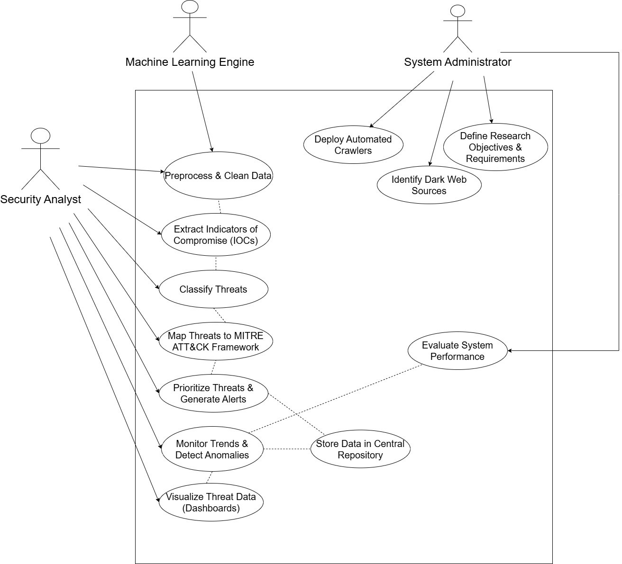
Figure 3: Usecase Diagram

The use-case diagram defines the functional requirements of the threat-intelligence automation plat- form by showing interactions between actors and system capabilities. System administrators perform configuration tasks such as defining objectives, identifying sources, and deploying crawlers. Auto- mated crawlers and ML engines act as internal actors responsible for data collection and intelligent threat processing. Security analysts interact heavily with the system’s analytical components-viewing dashboards, prioritizing threats, generating alerts, and monitoring trends. The diagram reflects how human and automated roles collaboratively support end-to-end threat intelligence generation. It clearly outlines the responsibilities of each actor and the system’s major use-cases.

Notation and Element Details
        - Actors:
          - Security Analyst: consumes dashboards, investigates threats, and responds to alerts.
          - System Administrator: configures sources, crawlers, and storage, and defines research objectives.
          - ML Engine: External ML/NLP services that preprocess, classify, and enrich data.
        - Use Cases:
          - Monitor Trends & Detect Anomalies, Visualize Threat Data (Dashboards), Prioritize Threats & Generate Alerts, Map Threats to MITRE ATT&CK Framework, Classify Threats, Extract Indicators of Compromise (IOCs), Preprocess & Clean Data, Evaluate System Performance, Define Research Objectives & Requirements, Identify Dark Web Sources, Deploy Automated Crawlers, Collect Dark Web Data, Store Data in Central Repository.
        - System Boundary:
          - Labelled as the threat-intelligence system; everything inside represents functionality im- plemented by the system.
        - Solid Association Arrows:
          - Connect actors to the use cases they directly participate in (e.g., Security Analyst Vi- sualize Threat Data, System Administrator Deploy Automated Crawlers). Arrowheads show the primary direction of interaction or initiation.
        - Dashed dependency arrows
          - Represent relationships such as includes/extends between use cases (e.g., Evaluate Sys- tem Performance depending on data being stored and visualised). These show that certain high-level capabilities rely on the successful execution of other use cases.

Sequence Diagram

20
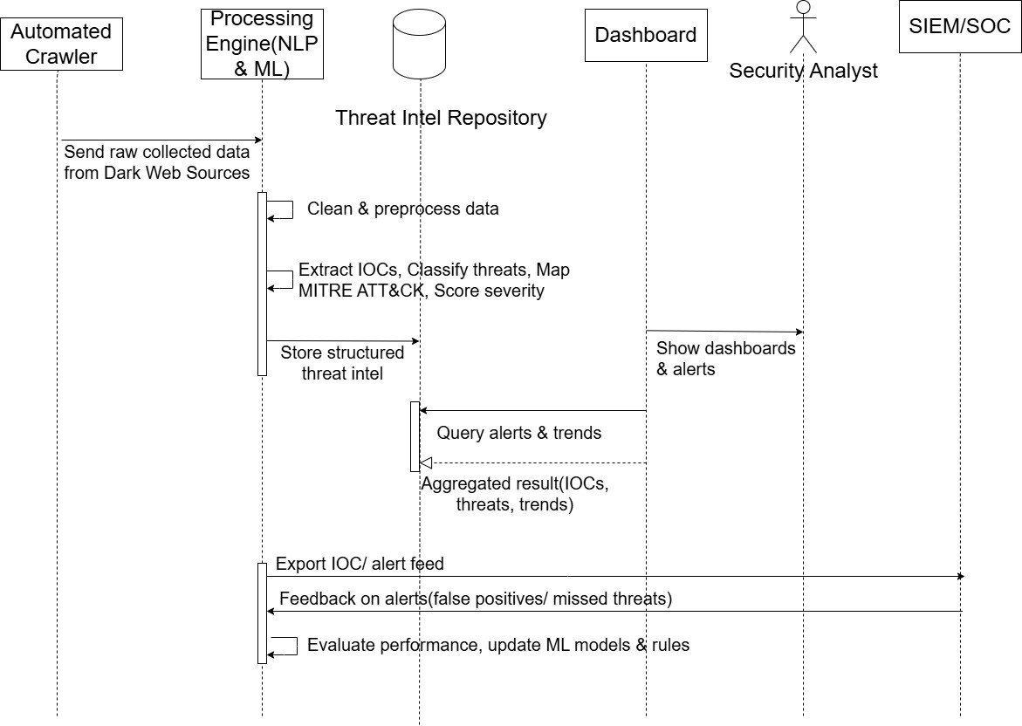

Figure 4: Sequence Diagram

The sequence diagram demonstrates the chronological flow of messages between system components as dark-web threat intelligence is collected, processed, and delivered. It shows how the system ad- ministrator initiates the workflow by configuring crawler sources, followed by a loop-driven data collection cycle executed by automated crawlers. Raw data is then forwarded to the processing en- gine where cleaning, IOC extraction, classification, MITRE mapping, and ML detection occur. The processed intelligence is stored in the central repository and becomes accessible for dashboards and analyst queries. Security analysts receive alerts, provide feedback on false positives, and contribute to continuous performance improvement. The diagram visualizes how each component collaborates in real time.

Activity Diagram
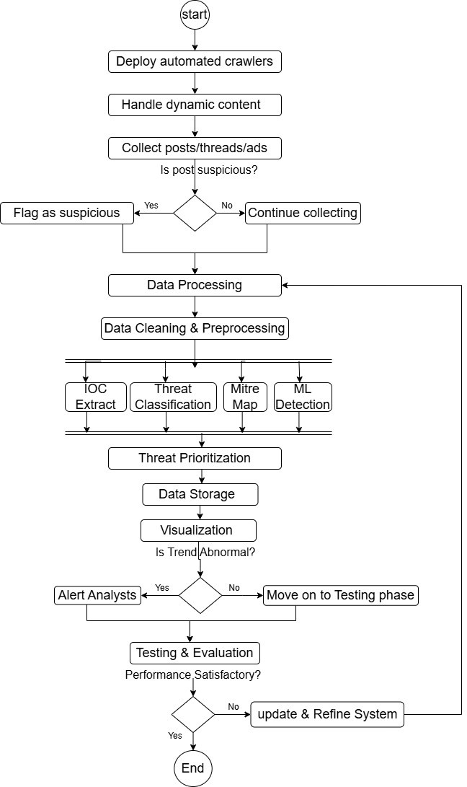
Figure 5: Activity Diagram

The activity diagram illustrates the complete operational flow of the automated threat-intelligence system, and the phases of data collection, processing, storage, and system evaluation. It shows how dark-web data is systematically gathered, filtered for suspicious content, and directed toward analyt- ical components for further processing. Each phase is represented as a sequence of activities with decision points controlling the flow based on outcomes such as suspicious post detection or trend abnormalities. Parallel activities such as IOC extraction, classification, MITRE mapping, and ML detection demonstrate the system’s multi-stage processing pipeline. The diagram also highlights an- alyst interaction during alerting and evaluation phases. Overall, it provides a high-level view of how raw dark-web content is transformed into actionable threat intelligence.

Entity-Relationship Diagram
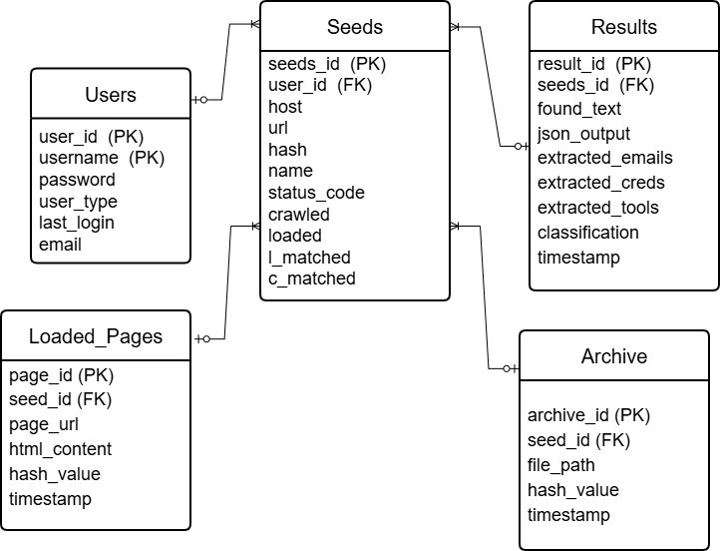

Figure 6: Entity-Relationship Diagram

The Entity-Relationship Diagram (ERD) defines the core data architecture of the Obscura dark-web threat-intelligence system by illustrating all major entities and how they interact. It models the com- plete pipeline.

Users
        - Purpose: Authentication, session handling, role-based access (admin, analyst).
        - Attributes
          - user id (PK)
          - username
          - password (hashed)
          - email
          - user type (admin/end user)
          - last login

          - other metadata
        - Relationships
          - 1 User Many Seeds (a user can start many crawling tasks.)

Seeds
        - Purpose: Represents starting points (onion URLs) provided by the user for crawling.
        - Attributes
          - seed id (PK)
          - user id (FK to Users)
          - host
          - url
          - hash (unique identifier)
          - name (label for seed)
          - status code (HTTP/Tor status)
          - Boolean Fields:
            - crawled
            - loaded
            - l matched
            - c matched
        - Relationships
          - 1 Seed Many Results
          - 1 Seed Many Loaded Pages
          - 1 Seed Many Archive entries

Results
        - Purpose: Stores NLP/AI-generated output from the crawled dark-web content.
        - Attributes
          - result id (PK)
          - seed id (FK)
          - found text
          - json output (raw extraction)
          - extracted emails
          - extracted credentials
          - extracted tools

          - classification
            - Malware
            - Exploit
            - Stolen Credential
            - Marketplace Listing
          - timestamp
        - Used For
          - NLP-based entity extraction
          - Threat Actor Profiling

Loaded Pages
        - Purpose: Stores all pages downloaded during crawling.
        - Attributes
          - page id (PK)
          - seed id (FK)
          - page url
          - html content
          - hash value
          - timestamp
        - Used For
          - Later NLP processing
          - Trend analysis via Kibana
          - Saving raw data

Archive
        - Purpose: Permanent storage of raw files, text dumps, screenshots, etc.

Attributes
          - archive id (PK)
          - seed id (FK)
          - file path
          - hash value
          - timestamp
        - Used For
          - Long-term storage
          - Threat actor profiling
          - Evidence

References
F/SOP/FYDP 02/06/00

Boshmaf, Y., Perera, I., Kumarasinghe, U., Liyanage, S., & Jawaheri, H. A. (2022). Dizzy: Large- scale crawling and analysis of onion services. CoRR, abs/2209.07202.
Collection no. 1 [Accessed: 2025-11-25]. (2025). Dark web intelligence market news. (2025).
Dark web statistics. (2025).
Documentation, A. (n.d.). Crawling dark web sites on the tor network [Accessed: 2025-11-25]. Dutta, A., Bhushan, B., & Kant, S. (2023). Snowball-miner: Integration of deep learning for extrac-
tion of cyber threat intelligence from dark web. International Journal on Recent and Innova- tion Trends in Computing and Communication, 11(9), 1986–1998.
Fuentes, M. R. (2025, May). Shifts in underground markets: Past, present, and future (tech. rep.).
Trend Micro Research.
Patra, T. K. (2025). Automated crawling and dark web intelligence: A review. Electronics, 14(21). Project, A. (n.d.). Ahmia: Search engine for hidden services on tor [Accessed: 2025-11-25].
Schro¨er, S., Canevascini, N., Pekaric, I., Widmer, P., & Laskov, P. (2025). The dark side of the web: Towards understanding various data sources in cyber threat intelligence. arXiv preprint arXiv:2504.14235.
Singh, A., Kumar, P., et al. (2021). Crator: A framework for crawling and analyzing tor hidden ser- vices. International Journal of Advanced Computer Science and Applications, 12(5).

